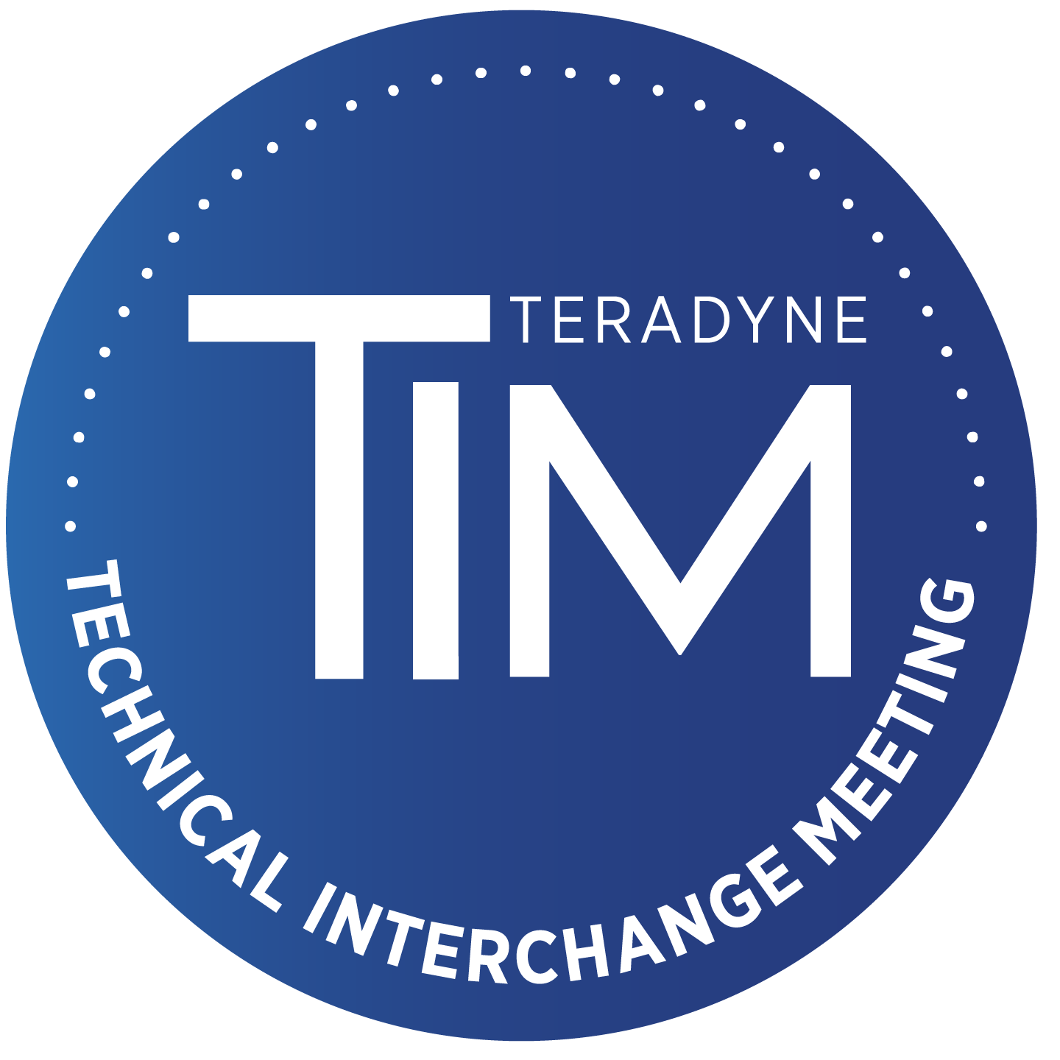

600 Riverpark Drive | North Reading, MA 01864 | 978-370-2700 | tim@teradyne.com

My paper and presentation materials have been reviewed in accordance with my employer’s policies (if this work was prepared in the course of my employment). I am authorized to present and publish the materials prepared for the 2024 Teradyne Technical Interchange Meeting (TIM) and to give Teradyne permission to copy and distribute the work as stated in this submission form.

Teradyne has told me that my work may be displayed or reproduced and distributed in multiple media, for example, via the eKnowledge website available to Teradyne customers, or on a USB drive distributed to Teradyne customers. Teradyne reserves the right to edit for length or format.

Teradyne is granted permission to use my submission in this fashion.

AUTHOR:
Signature

NAME:
Print

COMPANY:

PAPER TITLE:

DATE:

Please e-mail a copy of this form along with your paper and presentation submission to: tim@teradyne.com.

